BeCorp Network Design & Implementation Summary
Our task was to craft a well-structured plan that optimizes resource allocation and adheres to stringent security best practices. The following document is the resume of actions undertaken during the planning phase, implementation phase, monitoring, and troubleshooting or modifying phase.

PLAN
Three zones were initially laid out: the internal LAN for our five internal subnets (blue squares), our DMZ subnet (blue circle), our secured servers (pink), and on the other side of our firewall router (pastel), the external network to reach the WAN/ISP. Our choice of fixed subnets was also a choice in our initial plan to have better control over the routes and to better implement AAA.
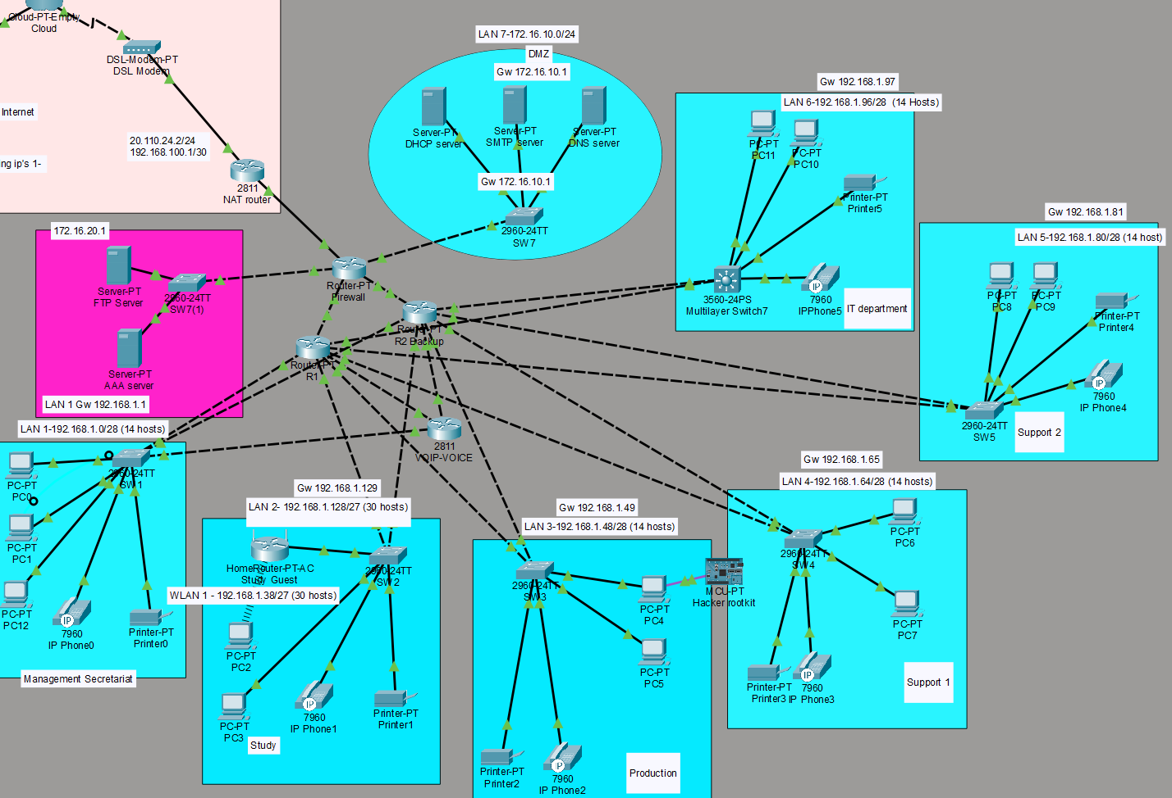

Network Architecture Overview
• Router1 (R1) and Router2 (R2) configured for gateway redundancy using HSRP.
• Firewall deployed as edge device performing NAT (PAT overload).
• SOHO/ISP router used as upstream gateway.
• Multiple VLSM-based LAN segments implemented.
- Wireless Router added to the study, to prioritize employee mobility.
- Lastly, added 2811 Router to handle voice, as our original network architecture did not handle VOIP connections, (see modify chapter) (CME + VLAN 20 + DHCP relay)

Subnet Design (VLSM)
Implemented Subnets:
• 192.168.1.0/28 (Gateway VIP: 192.168.1.1)
• 192.168.1.48/28 (Gateway VIP: 192.168.1.49)
• 192.168.1.64/28 (Gateway VIP: 192.168.1.65)
• 192.168.1.80/28 (Gateway VIP: 192.168.1.81)
• 192.168.1.96/28 (Gateway VIP: 192.168.1.97)
• 192.168.1.128/27 (Gateway VIP: 192.168.1.129)
Transit networks :
10.1.1.0/30
See Annexe 1
- In the reality the subnet 192.168.1.16/28 didn’t work in the setup, this is discussed further in modify chapter.

HSRP Redundancy
HSRP configured on all LAN interfaces between R1 and R2. Result: Automatic gateway failover without manual routing changes.
Key Commands Used:
standby <group> ip <virtual-ip>
standby <group> priority <value>
standby <group> preempt
show standby brief

Firewall Configuration & NAT
Inside Interface: 172.16.10.1/24 (ip nat inside)
Outside Interface: 192.168.100.2/30 (ip nat outside)
PAT Configuration:
ip nat inside source list NAT_INSIDE interface FastEthernet1/0 overload
Verification Commands:
show ip nat translations
show ip nat statistics

Static Routing Design
Default Route (Firewall → ISP):
ip route 0.0.0.0 0.0.0.0 192.168.100.1
Internal Routes (Firewall → Internal Router):
ip route 192.168.1.0 255.255.255.0 10.1.1.2
Routing Verification:
show ip route
show ip route static
Result: gave us better control over devices and structural layout.

ACL Implementation
Extended ACL 100 applied inbound on firewall interfaces.
Source \ Dest. | DHCP | DNS | AAA | FTP | DMZ | Internet
Management | ✅ | ✅ | ✅ | ✅ | ❌ | ✅
Study | ✅ | ✅ | ❌ | ❌ | ❌ | ✅
Production | ✅ | ✅ | ❌ | ❌ | ❌ | ✅
Support 1 + 2 | ✅ | ✅ | ❌ | ❌ | ❌ | ✅
IT | ✅ | ✅ | ✅ Admin | ✅ | ✅ Admin | ✅
Internet | ❌ | ❌ | ❌ | ❌ | ✅ | —
Example:
access-list 100 permit ip 192.168.1.0 0.0.0.255 any
access-list 100 deny ip any any
Applied using:
ip access-group 100 in

DMZ
Besides the internal and external configuration of our topology, we had planned a DMZ subnet to house the externally-facing services to the open Internet. This was used to protect our organization’s LAN from untrusted traffic.
Inside we planned to house also our servers, to give an additional layer of protection for them as well. But after careful thought, we separated the servers AAA + FTP from the DMZ despite having added the necessary layers of security.

Wireless routing
In order to benefit our employees, the study was configured with a wireless router. The range distance was decreased from 250m to 30m to make sure only certified employees can access. The password for this router is different from the router/switch passwords to enhance segmentation of users.

Final Network Behavior
• Automatic gateway failover via HSRP.
• Internal traffic routed correctly without NAT.
• External traffic NATed at firewall only.
• ISP return routing properly configured.
• No routing loops or asymmetric routing.
- Periphery devices (ie printers) were allocated the last available address in each subnet to always know how to find them.
- SSH was priviledged over Telnet in the design, with Telnet being disabled on routers and switches to avoid common breaches.

IMPLEMENTATION
Within our enterprise we identified and implemented secure configuration baselines for most technology. If given more time, we could have hardened further by implementing more hardening measures on the PCs, periphery devices. However, given our week, we focused on implementation on routers, switches, and servers for the most part. Our hardening measures can mostly be resumed as following:
- Access control, to include user accounts and authentication credentials
- Encryption
- Logging
- Least privilege
- Leveraging hardware security capabilities when possible
- Disabling of unused services, applications, and functionality
- Network connections
- Automatic session locking
- Removal of default accounts or names
Within the choice of our routers and switches, some of the commands were not fully implemented and count as some lessons learned about the choices of routers and switches.
With all these implementations, care was taken to save from running-config to startup-config.
We did not do baseline analysis as this topology didn’t have “real” traffic, but it was thought of in the case of a real-life scenario.

Redundancy Implementation
HSRP (Hot Standby Router Protocol)
Implemented between Router1 and Router2 for gateway redundancy.
Example Configuration (Router1)
interface fa2/0
ip address 192.168.1.51 255.255.255.240
standby 1 ip 192.168.1.49
standby 1 priority 110
standby 1 preempt
Key Commands Used
show standby brief
standby <group> ip <virtual-ip>
standby <group> priority <value>
standby <group> preempt
Purpose:
- Provides automatic gateway failover
- Prevents manual route changes during router failure

Firewall Configuration
Inside / Outside Interfaces
interface FastEthernet0/0
ip address 172.16.10.1 255.255.255.0
ip nat inside
interface FastEthernet1/0
ip address 192.168.100.2 255.255.255.252
ip nat outside

NAT Configuration
PAT (Overload)
ip nat inside source list NAT_INSIDE interface FastEthernet1/0 overload
NAT Access List
ip access-list standard NAT_INSIDE
permit 192.168.1.0 0.0.0.255
permit 192.168.2.0 0.0.0.255
permit 172.16.10.0 0.0.0.255
Verification Commands
show ip nat translations
show ip nat statistics
Purpose:
- Allow internal subnets to access ISP
- Perform address translation only when exiting outside interface
- Provide an extra layer of security between the external and internal

Static Routing
Default Route (Firewall → ISP)
ip route 0.0.0.0 0.0.0.0 192.168.100.1
Internal Routes (Firewall → Router1 or Router2)
ip route 192.168.1.0 255.255.255.0 10.1.1.2

ACL Implementation
Used to control traffic entering firewall.
access-list 100 permit ip 10.1.1.0 0.0.0.3 any
access-list 100 permit ip 192.168.1.0 0.0.0.255 any
access-list 100 deny ip any any
Applied to interface:
interface fa7/0
ip access-group 100 in

MONITOR
Ideally all the routers and switches would at minima have commands like the following:
Router(config)# login quiet-mode access-class myacl
Router(config)# login block-for 100 attempts 2 within 100
Router(config)# login on-failure log
Also, logging failures for key infrastructure should be saved in an external file. Care should be taken to choose the right ones, because logging all attempts could slow down operations.
As the objective of this activity was to build a topology, we did not spend time in developing an on-going monitoring of future activities. Ideally there would also be updates to baseline studies to monitor the chokepoints of expanding operations.
That being said, we did add a hacking computer + hacker rootkit during our testing phases to monitor discovery hacks and man-in-the-middle, to try and harden our system ACL to specifically target these types of scenarios.
Pings are allowed into IT department for logging methods, but the packet cannot return to sender, it gets blocked at the multilayer switch.

MODIFY
Multiple troubleshooting journeys were undertaken while implementing our topology.
* Implementation of the AAA server. This caused some of our passwords to fail, and routes had to be reconfigured.
* VOIP. The routers that we picked in the original topology do not support telephony commands, despite trying several work arounds. In the end, we added an additional router that could be configured to meet the demands of the VOIP. This seemed a logical fix to a working enterprise configuration instead of downing the infrastructure and restarting over. All VOIP was configured to Vlan 20 with the IP/Gateway of 10.50.20.0/24 10.50.21.1 allowing for better segmentation and isolation from PC use.
In summary,
interface FastEthernet0/0.20
encapsulation dot1Q 20
ip address 10.50.20.1 255.255.255.0
ip helper-address 172.16.10.20

* Subnetting. For some reason, our subnet 192.168.1.16/27 subnet for the study did not implement properly, despite troubleshooting. So we decided to apply a new subnet of 192.168.1.128/27 (end of the list for internal subnetting) to work around. That seemed to have fixed the problem.
*VLAN. A bit hit or miss, the plan was to have VOIP on VLAN 20, IT to have a secured VLAN, but we ran out of time to make
Identified and resolved:
• Incorrect HSRP virtual IP assignments
• Routing loops between firewall and SOHO router
• Inactive static routes due to unreachable next-hop
• NAT translating internal-to-internal traffic
• Interface up/down link issues
Some command prompts could not be undertaken, but were thought of in the planning and implementation phase, these include (as well as others listed in monitoring):
- security passwords minimum length
- automatic patches
- firewall: disable key words
- firewall settings on individual PCs
Troubleshooting Techniques Used
Routing
show ip route
show ip route static
show run | include ^ip route
Interface Status
show ip interface brief
show interface <interface>
ARP
show arp
Connectivity
ping <ip>
traceroute <ip>
Access-list
Show access-list
The use of AI was used in the case of several attempts at troubleshooting failures, expanding our ability to think of additional techniques in real time to test on our network.

CONCLUSION
In summary, our set-up provides a defense in depth approach, initiating security considerations at all levels of the OSI model:
OSI Layer | Layer Name | Security Measure Implemented | Device / Location | Purpose / Security Impact
Layer 7 | Application | DMZ Server Segmentation (DHCP / AAA / Services – 172.16.10.20) | DMZ Network | Isolates critical services from internal LAN. Reduces direct exposure of internal hosts.
Layer 7 | Application | VoIP Segmentation (Voice VLAN 10.50.20.0/24) | VoIP Router | Separates voice services from data traffic. Limits attack surface & lateral movement.
Layer 6 | Presentation | NAT/PAT Address Translation | Firewall | Hides internal IP structure from external networks. Adds obscurity layer for internal topology.
Layer 5 | Session | Stateful Traffic Control via Firewall Routing & NAT | Firewall | Controls session establishment between LAN, DMZ, and ISP. Prevents unauthorized session persistence.
Layer 4 | Transport | Extended ACL (IT_POLICY) | SW6 (IT Switch) | Controls traffic based on source/destination subnets. Prevents unauthorized lateral communication.
Layer 3 | Network | Static Routing with Controlled Default Routes | Routers & Firewall | Prevents unintended traffic leakage to ISP. Ensures symmetric routing and secure path enforcement.
Layer 3 | Network | HSRP Redundancy | Router1 & Router2 | Maintains gateway availability. Prevents denial of service from single gateway failure.
Layer 3 | Network | Network Segmentation (VLSM Subnets) | LAN Design | Isolates departments. Limits broadcast domains and reduces attack propagation.
Layer 3 | Network | Dedicated Transit Networks (/30 Links) | Router ↔ Firewall / Router ↔ VoIP | Minimizes exposure of point-to-point links. Reduces attack surface and misrouting risks.
Layer 3 | Network | Voice VLAN Routing via Static Routes | Routers | Controls path to 10.50.20.0/24. Prevents default-route misrouting to ISP.
Layer 2 | Data Link | VLAN Segmentation (Data vs Voice vs IT) | Switch Infrastructure | Broadcast isolation. Reduces ARP spoofing impact scope. Contains internal threats.
Layer 2 | Data Link | Outbound ACL Placement at Switch Edge | SW6 | Enforces containment at subnet boundary. Improves monitoring visibility of attack attempts.
Layer 1 | Physical | Removal of Duplicate Cabling | Router1 / VoIP Router | Prevented unintended loops and duplicate L2 paths. Improved physical-layer integrity.

